Internship Title: - **IoT based flood prediction system.**

Student Name: - **Avin Shejwal**

Contact details: -

* Email ID: <2019avin.shejwal@ves.ac.in>

GitHub link: - <https://github.com/Tinkerers-Lab-VESIT-ETRX/IoT-based-flood-prediction-system-2>

**INDEX:**

|  |  |  |
| --- | --- | --- |
| Sr. No. | Content | Page No. |
| 1 | Introduction | 2 |
| 2 | Literature Review | 4 |
| 3 | Proposed Solution | 6 |
| 4 | Result | 8 |
| 5 | Advantages | 13 |
| 6 | Disadvantages | 13 |
| 7 | Applications | 14 |
| 8 | Learning Outcomes | 14 |
| 9 | Conclusion | 15 |
| 10 | References | 15 |
| 11 | Appendix | 16 |

**INTRODUCTION:**

* Existing Problem: -

Floods are among the most common disasters and natural hazard in the world, affecting human lives and causing severe economic damage. It is understood that flood risks will not decrease in the future and with the beginning of climate change, flood intensity and frequency will threaten many regions of the world. To minimize the extent of damages caused by flood, warning systems to inform the people of the disaster should be implemented in high-risk areas. This system will be able to reduce the damages of flood.

The system should be designed to be able to detect the rising levels of water so appropriate warnings to the authorities and the public can be send. In general, such a flood notification system component will consist of microcontrollers, sensors, modem and computers.

Lives had been lost because of flood. Flood may happen anytime during the three season and at any area around the world. The after effect which have been seen about flood disaster encourage us to find the best solution for the natural hazard. A detection and monitoring system for flood is hence proposed as a measure to lessen the risk of damages caused by flood to life and property.

This system will be a good opportunity in making the operation more efficient and synchronize. From last decade, there are many varieties of systems have been produced to prevent this problem from happen again. Therefore, new system needs to invented and applicable from any time and any area to solve this problem effectively by using best technology that using in world currently, and the system should be simple and useful.

* Overview: -

As, a solution to the existing problem, an IoT based approach is taken to design a Flood prediction system, using various sensors and microcontroller, on proteus software. From the microcontroller, the data for the above parameters, is uploaded to the Firebase, which is central database. For the end consumer, a web app is designed, which retrieve the data from Firebase and display the readings in a graphical format.

This project predominantly combines two-study fields-based control systems and data gathering technique, to create a large database system depending on the employed attributes to generate the presented data.

* Purpose: -

To create an affordable and reliable solution for existing problem, by an IoT based approach. The flood parameters of various water sources such as rivers or sea will be tracked and information are transferred to the cloud server. In this way, we are transmitting the real-time flood information. Due to uploading in cloud server the information can be viewed from any part of the world, provided an internet connection. The system will function with tracking and monitoring environmental circumstances such as temperature, humidity, rain fall status, water flow rate, and water level with sensors and whenever the readings exceed a selected threshold limit for each the end user will be alerted.

**LITERATURE REVIEW:**

* This uses the Machine Learning to Detect flood which occurs on road and other places. The ultrasonic which is used to detect flood is a sufficient value to accurately find the flooded areas but this system uses infrared sensors which can detect flood because of thermal heat effects which are not accurately described in values as by using the ultrasonic sensors. This Infrared sensor which can sense ground temperature and variations in temperature is used in machine learning and is able to detect the floods but not that accurately[1].
* Three components used in this system, which is composed of sensor detecting values, networking which sends sensors value, processing the sensors value which is sent by the network and transmitting of the values to the user or the operator. The water level condition is monitored as well as monitoring the rain intensity. In this they are using GPRS as a communication of sensors and sending the values to web- applications like Backend which in turn is updated in front- end for user or the operators to see which is not reliable[2].
* For the development of flood risk reduction, the crucial role is to first understand the hazardous phenomenon and the highly dangerous consequences on the society. The IOT based systems are preferred by researchers because it senses the data from different sensors without human interference. These systems are combined with water level sensors such as ultrasonic for water level detection but the major drawback is that it misses alert system [3].
* **Hardware Required:**

|  |  |
| --- | --- |
| Sr. No. | Name of Hardware |
| 1 | Arduino Mega |
| 2 | Temperature and Humidity Sensor DHT11 |
| 3 | Raindrop Sensor |
| 4 | Ultrasonic sensor |
| 5 | Water flow sensor |
| 6 | Jumper Cables |

* **Software Required:**

|  |  |
| --- | --- |
| Sr. No. | Name of Software |
| 1 | Arduino IDE |
| 2 | Proteus |
| 3 | Firebase |
| 4 | PyCharm / Python IDE |
| 5 | Sublime Text (for HTML, JavaScript, CSS) |

**PROPOSED SOLUTION:**

* Block Diagram: -

Arduino

Mega

Temperature and Humidity Sensor DHT11

END USER

WEB APP

Raindrop Sensor

CLOUD

SERVER

(FIREBASE)

Ultrasonic sensor

ACCESS POINT

(WIFI HOME

ROUTER)

Water flow sensor

Figure 1- Block diagram

* Flow Chart: -

Start

Read the values from sensors

Upload values to Real Time Database

Transfer values to Webapp

Select the Sensor

No

Selecting correct Date on Webapp

Yes

Graphical Representation of selected sensor

End

**RESULT:**

* **Circuit simulation on Proteus:-**

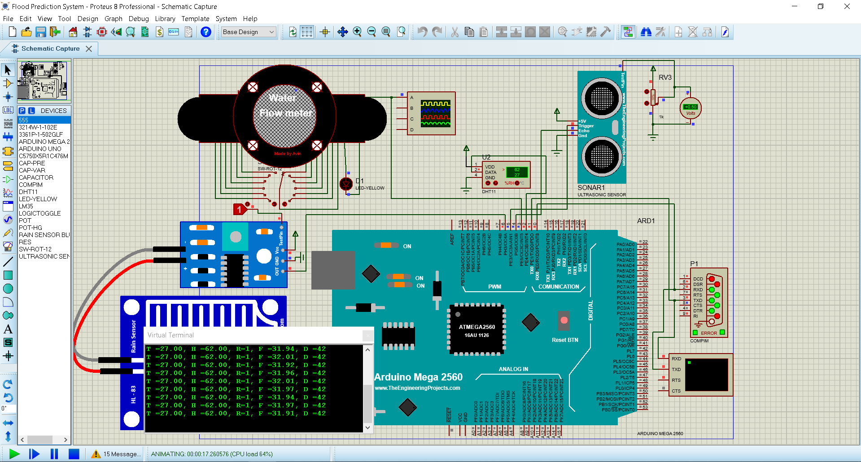

* **Firebase Real-Time Database:-**

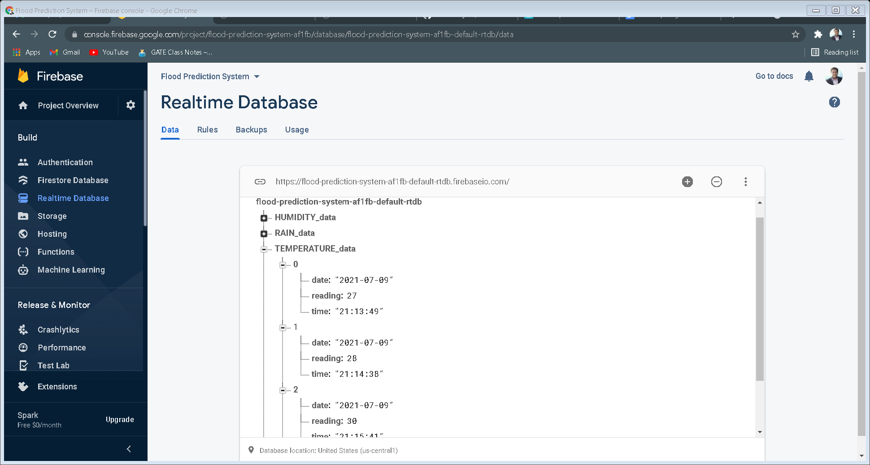

* **Deployed Web App**: -

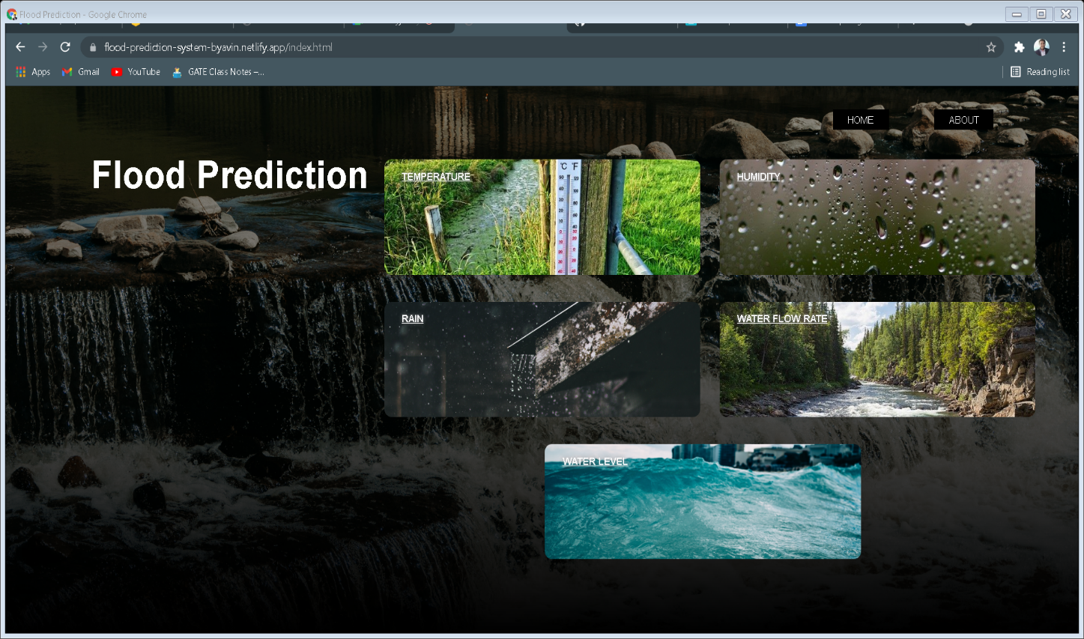

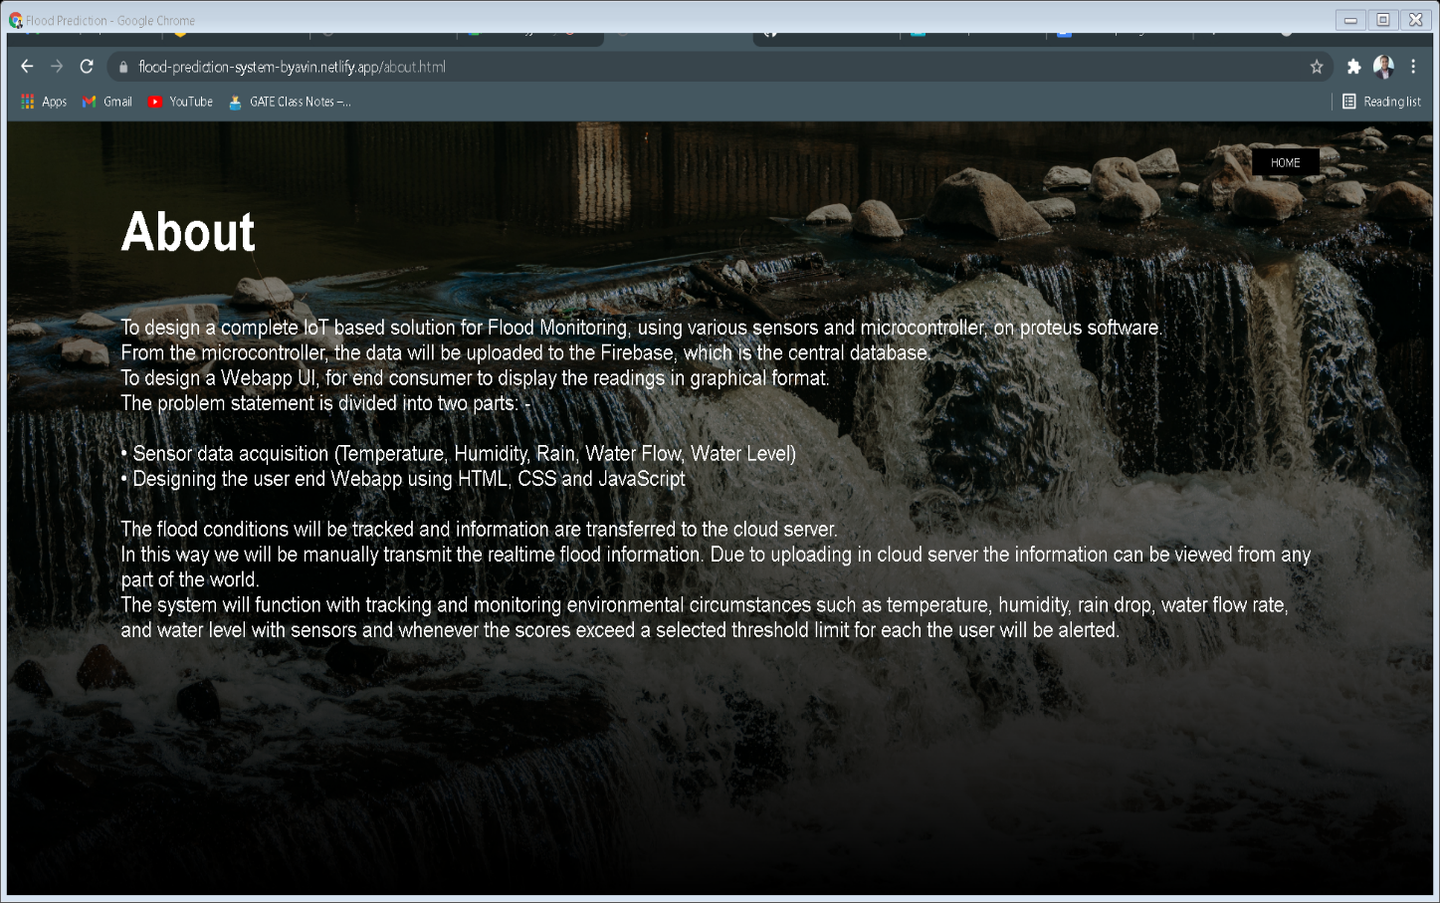

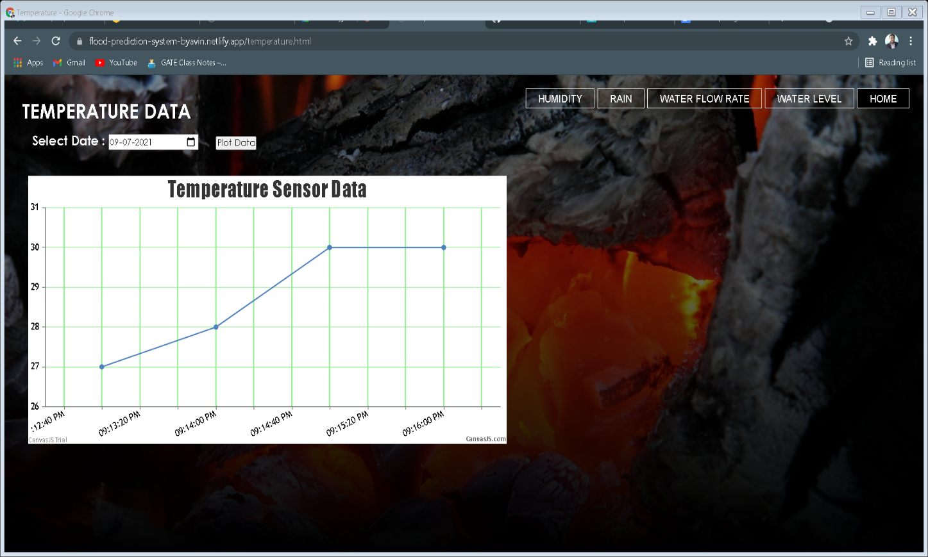

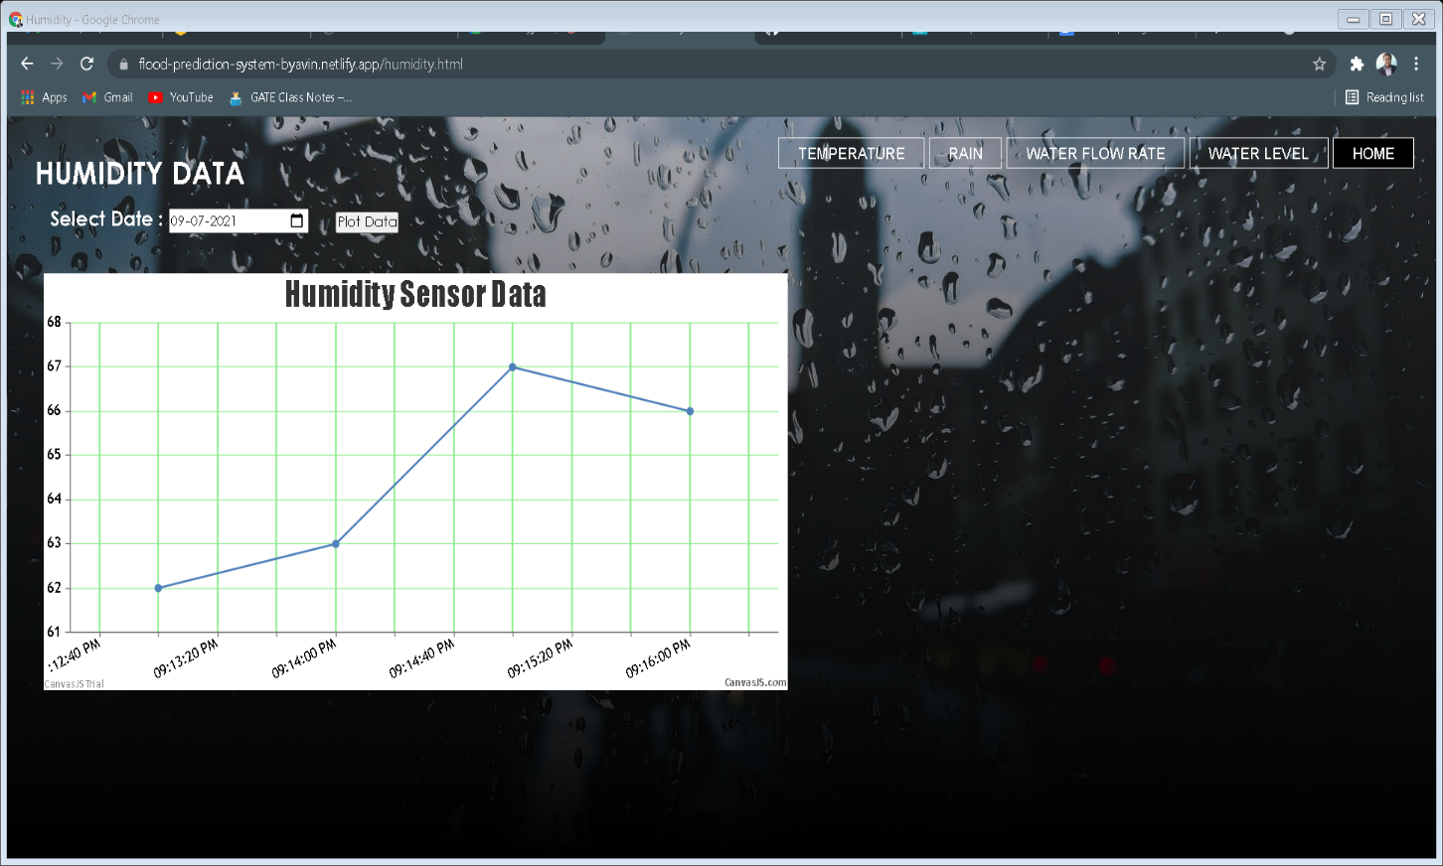

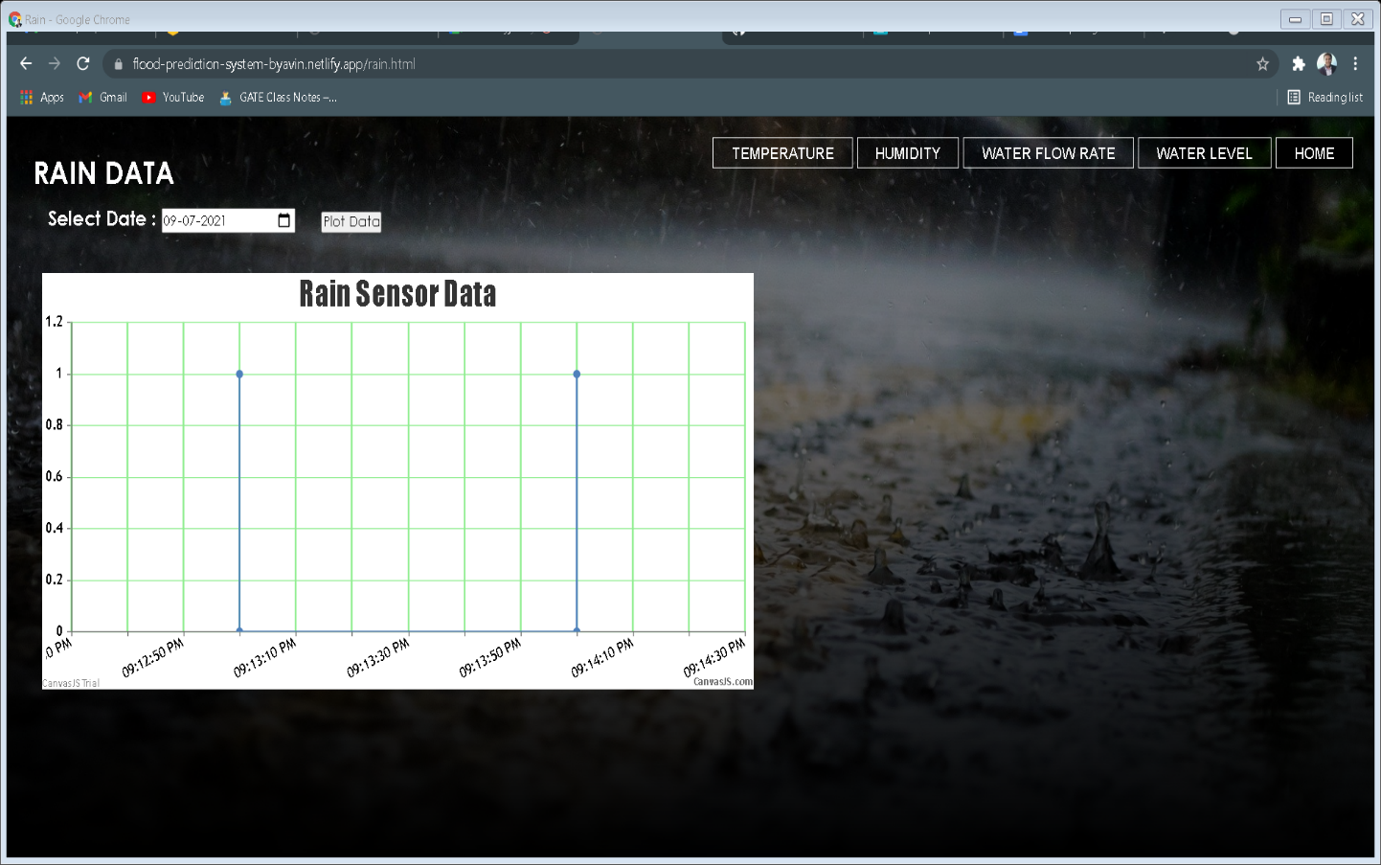

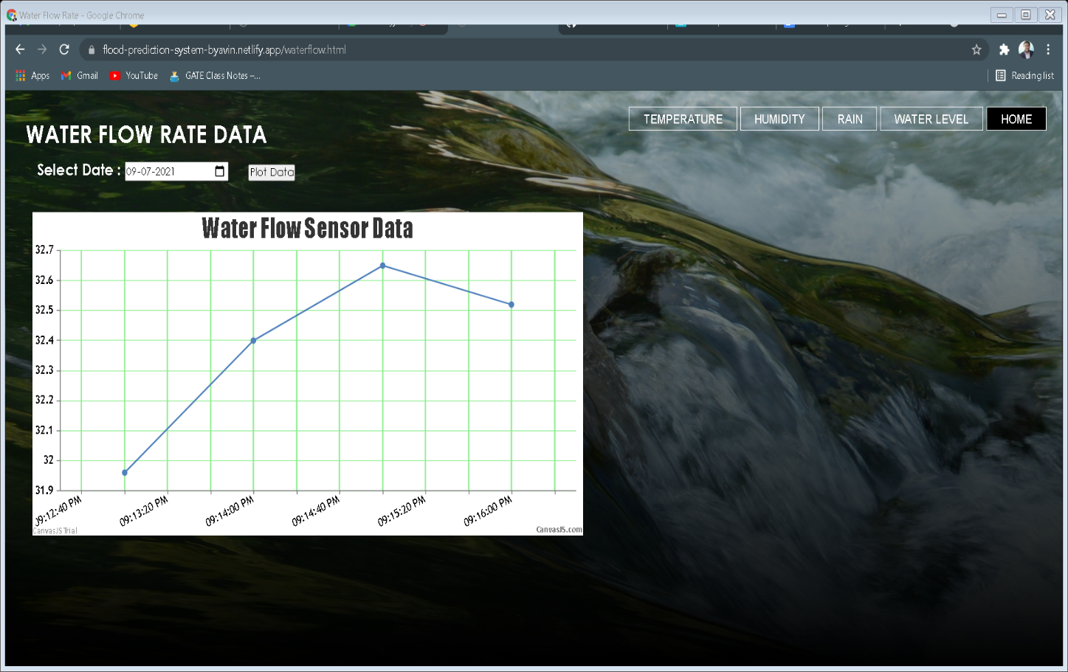

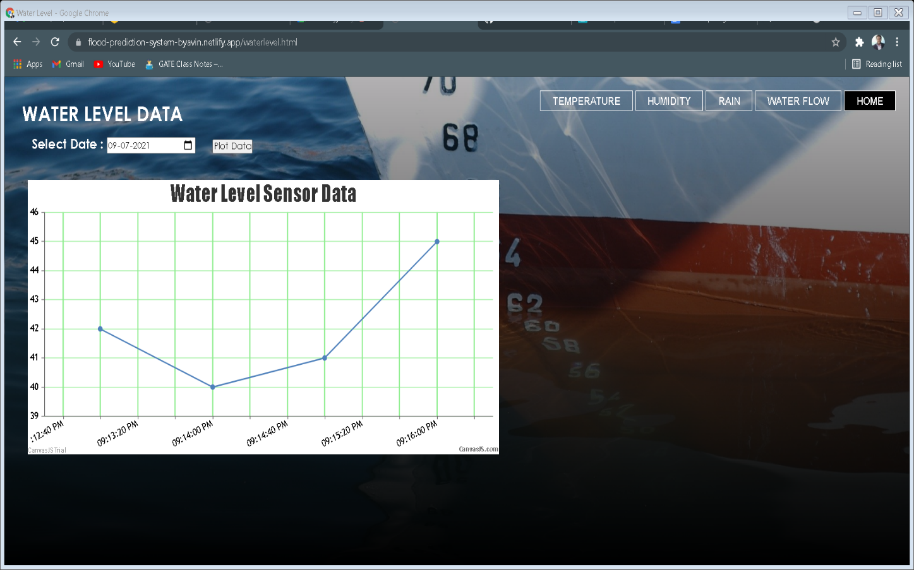

* URL for deployed web application:-

<https://flood-prediction-system-byavin.netlify.app>

**ADVANTAGES:**

1. IoT Flood prediction system project using Arduino is fully automated, and doesn’t require human attention.

2. Low power consumption, highly accurate, faster response time, and much more efficient.

3. Easy to understand and build.

4. Low cost of build and maintenance.

5. Real-time data transfer, via cloud server, to any place on earth.

6. Easy to use, end user web app, displaying data in graphically.

**DISADVANTAGES:**

1. Difficult to transmit real-time data, to end user in cases of extreme weather conditions.

2. In case of network disturbances, real-time data may not get transmitted.

3. Chances of failure of the sensor, if maintenance of the sensors are not done.

4. Work for small and particular area.

**APPLICATIONS:**

1. The Flood Prediction, plays crucial role in field of agriculture, as the growth of crops are heavily affected by floods.

2. Ensures proper and safe working conditions in industries and mines.

3. To manage the vehicular traffic in efficient way.

4. Enables us to ensure proper safety of people.

5. Helps to determine adequate water level for boating.

6. Gathers valuable information for each flood parameter, will help in predicting the best/safe conditions for working.

7. Flood monitoring and forecasting helps government, and security forces to ensure proper safety of citizen

**LEARNING OUTCOMES:**

1. IoT circuit design simulation on Proteus.

2. Transferring real-time data, to Firebase real-time database using python programming.

3. Extracting real time data, from Firebase real-time database, and plotting it graphically using HTML, JavaScript and CSS.

4. Web app designing, using HTML, JavaScript and CSS.

5. Web app deployment.

6. Technical writing skill.

**CONCLUSION:**

This project highlights the possibility to provide an alert system that will overcome the risk of flood. It can also contribute to multiple government agencies or authority that can ultimately help the society and mankind about the flood like hazardous natural disaster. The model proposed has been already tested and it is working as presented in this paper. It will monitor each and every aspect that can lead to flood. If the water level rises along with the speed, it will send an alert immediately. It also ensures increased accessibility in dealing 8 and reverting to this catastrophic incident. In summary, it will help the community in taking quick decisions and planning against this disaster.

**REFERENCES:**

[1] Mustafa Mousa, Christian Claudel, “Poster Abstract: Water Level Estimation in Urban Ultrasonic/Passive Infrared Flash Flood Sensor Networks Using Supervised Learning”, IEEE2014.

[2] E. Basha, et al “Design of early warning flood detection system for developing countries,” in Proc. of the Conference on Information and Communication Technology and Development, Dec 2007.

[3] M. Mathematic and R. Grace, “Flood alert management system using iota and microcontroller,” International journal of innovative research in computer and communication engineering, vol. 5, no. 4, April 2017.

**APPENDIX:**

* Source Code (Web App)

<https://github.com/Tinkerers-Lab-VESIT-ETRX/IoT-based-flood-prediction-system-2/tree/main/website>

* Source Code (Arduino Code)

<https://github.com/Tinkerers-Lab-VESIT-ETRX/IoT-based-flood-prediction-system-2/blob/main/Flood_Prediction_System.ino>

* Source Code (Python data upload)

<https://github.com/Tinkerers-Lab-VESIT-ETRX/IoT-based-flood-prediction-system-2/blob/main/FLOOD%20PREDICTION%20SYSTEM.py>